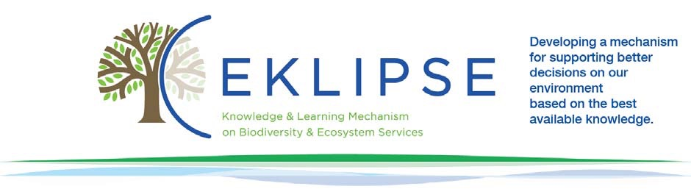
EKLIPSE Document of work:
From Global to EU and vice versa (DG R&I)
SCOPING Phase ended (29/03/2018)

Content:
General Information
Background of the Call
(Refined request questions)
Suggested Methods
Logbook
References

Annex1: Text of the Call for Knowledge
Annex 2:
Annex 3:
Annex 4:
Annex 5:

GENERAL INFORMATION
During the second Call for Requests launched by EKLIPSE in July 2017, a request entitled "What needs to be done to better integrate research and knowledge on biodiversity and ecosystem services from the global to the European level, and vice versa?" was put forward by the European Commission, DG R&I.

The type of knowledge sought by this request relates to seeking greater understanding or predictive power, seeking appropriate methodologies, understanding public opinions and/or perceptions, and seeking people's understanding of an issue.

In order to refine the request, scoping activities have been carried out:
- Call for Knowledge, supported by interviews, in order to identify already existing knowledge on the request
This document of work describes the results of the scoping activities as well as the background of the request. It does not foresee the need for the launch of a call for experts.
Requesters: Marco Fritz(European Commission, DG R&I)
Date of first meeting with requesters and EKLIPSE KCB and methods experts:
Expected deadline for deliverables: before 17/03/18.

Topic of the request: What needs to be done to better integrate research and knowledge on biodiversity and ecosystem services from the global to the European level, and vice versa?
BACKGROUND OF THE CALL
Context and justification
The request is based on the need to translate the outcomes of global science-policy processes on biodiversity and ecosystem services into action at the European scale and, vice versa, to ensure that European science-policy processes contribute to the global debate.
To our knowledge, no strategic analysis has been made to understand:
- How global processes and outcomes dedicated on research and knowledge on biodiversity and ecosystem services (e.g. from the SDGs, CBD, IPBES or IPCC), could concretely be translated into European research and innovation policy (Horizon 2020 and FP9); or
- How best European research and innovation policy processes and deliveries (projects, knowledge, scientific capacity) could strategically feed into global processes.
Regarding knowledge on biodiversity and ecosystem services, at global intergovernmental level, decisions of the Convention on Biological Diversity (based on SBSTTA recommendations) and publications (such as the Global Biodiversity Outlook), and assessments and processes of the Intergovernmental Science-Policy Platform on Biodiversity and Ecosystem Services all recommend to further work on knowledge questions, to undertake research, or to invest in tools and capacity building.
Interactions between European and global level take place at the level of scientists, projects, (joint) programming, assessment review and adoption or decision making by parties, but a more strategic approach could further improve processes and results.

SUGGESTED METHODS
As part of the Call for Knowledge, EKLIPSE has developed a questionnaire (See Annex 1) and contacted representatives from key organisations to share their knowledge of this issue and suggest recommendations for a workshop and its outcomes. The provided deadline to complete the questionnaire was 29th March 2018.
In early May, one-on-one interviews over Skype took place, with key actors on this topic, as identified by DG R&I.
The resulting data will be compiled and presented by EKLIPSE at a workshop organized by DG R&I on this topic on June 1st 2018. The workshop, where Eklipse will prove support in the design and facilitation,will look at the methodologies used by others to interpret the international assessments into prioritisation for their own needs, and will help to facilitate a process with relevant players on the steps forward in better linking European and Global science and policy on biodiversity and ecosystem services.
As the discussion on the big lines (e.g. societal challenges of H2020) as part of the FP9 discussionis in May, the workshop is expected to feed into the refinement and spelling out of these big lines.

LOGBOOK
The logbook describes the agenda of exchanges with the Requester, KCB Env and the Methods group and the contents discussed during the meetings.
Date | Participants | Topic | Platform
11 Jan. 2018 | Marco Fritz (DG R&I), Sofie Vandewoestijne (DG R&I), Tiago Freitas (DG R&I),  Juliette Young (CEH – EKLIPSE), Heidi Wittmer (UFZ – EKLIPSE), Jorge Ventocilla (RBINS – EKLIPSE), Estelle Balian (RBINS – EKLIPSE). | Further define DG R&I’s request | In person and Online (Gotomeeting)
19 Feb. 2018 | Marco Fritz (DG R&I), Heidi Wittmer (UFZ – EKLIPSE), Josefina Enfedaque (DG R&I), Juliette Young (CEH – EKLIPSE), Allan Watt (CEH – EKLIPSE), and Jorge Ventocilla (RBINS – EKLIPSE). | Define questions in the call for knowledge | In person and Online (Gotomeeting)
17 April 2018 | Marco Fritz (DG R&I), Heidi Wittmer (UFZ – EKLIPSE), Juliette Young (CEH – EKLIPSE) | Define workshop design | In person and Online (Gotomeeting)

REFERENCES

Annex 1: Text of the call for Knowledge

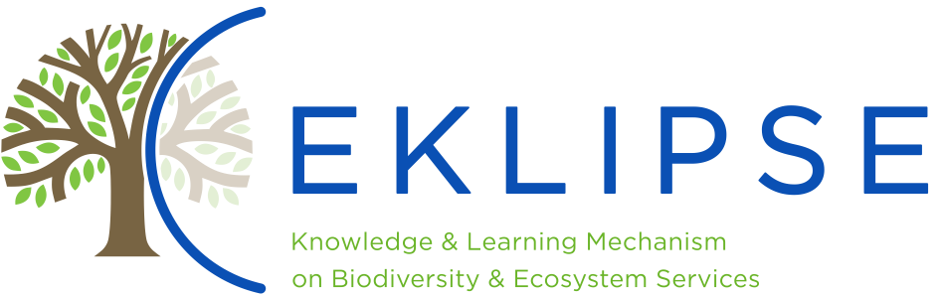

Call for Knowledge (March 2018)

A request, entitled "What needs to be done to better integrate research and knowledge on biodiversity and ecosystem services from the global to the European level, and vice versa?" was put to EKLIPSE by the European Commission DG R&I in the second Call for Requests.
The request is based on the need to translate the outcomes of global science-policy processes on biodiversity and ecosystem services into action at the European scale and, vice versa, to ensure that European science-policy processes contribute to the global debate.
However, no strategic analysis has been made to understand:
- How global processes and outcomes dedicated on research and knowledge on biodiversity and ecosystem services (e.g. from the SDGs, CBD, IPBES or IPCC), could concretely be translated into European research and innovation policy (Horizon 2020 and FP9); or
- How best European research and innovation policy processes and deliveries (projects, knowledge, scientific capacity) could strategically feed into global processes.
As part of the scoping phase, and to inform a workshop organised by DG R&I in June 2018, we are inviting representatives from key organisations to share their knowledge of this issue, and suggest recommendations for the workshop and its outcomes.
We invite you to complete this form by the 29th March. The results of this exercise will be collated, synthesized and communicated to DG R&I to inform the organisation of the workshop in June 2018.
*Required
Email address *

Name *

Would you rather fill out this form, or be contacted for a phone interview? *
Fill in the form
Request an interview

(Only applicable if you choose a phone interview: You are requesting a phone interview. Please continue to the next section and submit this form and we will email you shortly to arrange a convenient time.
Note that once a time has been set, we will send a consent form for you to sign prior to the interview, detailing the aims of this data collection, data storage and anonymity.
Many thanks for completing this form. We will be in touch with you shortly if you have requested an interview. The results of this exercise will be compiled, synthesized and presented to DG R&I in preparation of the workshop in June.)

Do you know any strategic analysis (projects, papers, reports, grey literature) on the inter-linkages (going both ways) between relevant global processes and European funded research, knowledge and/or policy recommendations or developments? *
Yes
No

If you do know of such existing or forthcoming analyses, please provide details here

What are your experiences of processes that have tried to better integrate research, knowledge, or policy recommendations on biodiversity and ecosystem services from the European to the global level, and vice versa? *

Were these experiences positive or negative? What made them useful or not? *

Do you have any suggestions on how to better integrate research, knowledge, policy recommendations on biodiversity and ecosystem services from the European to the global level, and vice versa? *

DG R&I will organise a workshop to address the issue. Who from your organisation should be present? Please provide their name, function, contribution to the workshop, and email address. *

Which key organisations do you think should be invited to the workshop? Organisations we are inviting include IPCC, Future Earth, IPBES, CBD, IUCN, GBIF, GEO-Bon, Belmont Forum, BiodivERsA. *

What recommendations would you have for the format of the workshop? For example, would you like participatory sessions, plenary discussions, information sessions, focus on specific issues/aims? *

What outputs and outcomes of the workshop would be most useful for you and your organisation? *

Many thanks for completing this form. We will be in touch with you shortly if you have requested an interview. The results of this exercise will be compiled, synthesized and presented to DG R&I in preparation of the workshop in June.

Please specify whether you would like the information used in this form to be anonymised
Yes
No

A copy of your responses will be emailed to the address you provided

